The EASA’s Annual review of Safety Recommendations
Mario Colavita – Safety Investigation & Reporting Section Manager

Introduction
The first edition of the EASA’s Annual Safety Recommendations Review was issued in 2007.
At its 10th edition, this publication provides now a comprehensive overview on the activity and progress on the follow-up actions performed by EASA in response to recommendations addressed to the Agency by Safety Investigation Authorities in relation to the investigation of Accidents and Serious Incidents, or originating from safety studies.
The paper will report the main elements described in the Annual Report as well as its link to the European Plan for Aviation Safety through the identification of several key safety topics.

Lecturer short introduction
EASA Safety Investigation officer since August 2014, and Head of the Safety Investigation and Reporting Section since February 2017.
Former Air Safety Investigator at ANSV (Italian Safety Investigation Authority) where he has been working for 7 years. In that timeframe he was also in charge of the Proactive Prevention Office.
Before joining the ANSV, Mario Colavita has been an Officer of the Italian Air Force since 1993. His military career was entirely performed at the Flight Test Centre that he left with the position of Head of the Structural Materials Department.
From 1990 to 1993 he was a Junior Scientist at the Centro Sviluppo Materiali in Rome, the R&D centre of the main Italian steelmaker company.
After graduating in Chemistry at the University “La Sapienza” of Rome in 1988, he got a MSc in Corrosion Science at the University of Ferrara (Italy) and a MSc in Advanced materials at Cranfield University (UK), as well as the completion of the Aviation Safety Certificate at the University of Southern California (US).

The EASA’s Annual review of Safety Recommendations

Background
At the European Union level, the principles governing the investigation of accidents and serious incidents are defined in Regulation (EU) 996/2010 of the European Parliament and of the Council of 20 October 2010 on the investigation and prevention of accidents and incidents in civil aviation.
Regulation (EU) No 996/2010 implements international standards and recommended practices as described in Annex 13 to the Chicago Convention on International Civil Aviation. It sets down an obligation for each Member State of the European Union (EU) to establish an independent permanent national civil aviation safety investigation authority, which shall investigate accidents and serious incidents in order to improve aviation safety and prevent future occurrences without apportioning blame or liability. Investigation reports and the related safety recommendations shall be communicated to the concerned aviation authorities for consideration and appropriate action, as needed.
Regulation (EC) No 216/2008, which established the European Aviation Safety Agency (EASA), states that “Results of air accident investigations should be acted upon as a matter of urgency, in particular when they relate to defective aircraft design and/or operational matters, in order to ensure consumer confidence in air transport”.

EASA management of the safety recommendations
EASA assigns a high priority to the follow-up of safety recommendations and has established effective procedures to that effect:
- EASA delivers the first response to incoming recommendations within 90 days;
- The safety recommendations process is subject to continuous internal monitoring until all corrective actions are closed;
- The Agency receives assessments of its responses from Safety Investigation Authorities and can identify when opinions diverge. In this context, EASA considers the assessment given by the safety investigation authority on the appropriateness of the mitigation measures when closing the recommendation.
Furthermore, the Agency maintains transparency with respect to its decisions and actions, in line with its safety mission, and keeps a high level of cooperation in working with the European Network of Civil Aviation Safety Investigation Authorities (ENCASIA) - WG6 on Safety Recommendations.
To fulfil its mandate, the Agency also monitors safety recommendations that are issued to other aviation and non-aviation addressees.
Since 2011, a process to assess and mitigate safety risks at the European level has been established. At the heart of this system is the concept of safety risk management, comprising hazard identification, risk assessment and decision-making resulting in on the best agreed course of action to mitigate those risks. EASA, Member States (MS) and industry work closely together in this process. At the European level, this process is coordinated by the Agency and documented in the European Plan for Aviation Safety (EPAS).
The EPAS identifies the key safety issues as well as the agreed safety actions to resolve or mitigate the hazards.
Safety recommendations are one of the key inputs to the safety risk management process. They provide information on the hazards as well as proposed solutions to mitigate the associated safety risks to the aviation system.

The Annual Safety Recommendations Review
The Annual Safety Recommendations Review (ASRR) is the document which provides an overview on the follow-up performed by EASA in response to recommendations addressed to the Agency by Safety Investigation Authorities in relation to the investigation of accidents and serious incidents or originating from safety studies.
The ASRR has now reached its 10th edition, reaching a level of maturity that is proportionate to the key role played by EASA for European aviation safety, in particular both as Certification Authority and Regulator.
Owing to EASA’s position in the system, the Agency is able to take action with respect to systemic problems and other issues in the management of risk.

The document collects and presents the following information:
- General statistics data on the safety recommendations addressed by safety investigation authorities to EASA in 2016;
- Replies that EASA has given to safety recommendations in 2016 and;
- Safety topics that have been processed with actions taken.

Safety Recommendations received in 2016
During 2016, EASA received a total of 88 safety recommendations. Figure 1 shows the total annual number of safety recommendations that the Agency has received over the last 10 years, and its steady trend since 2012.

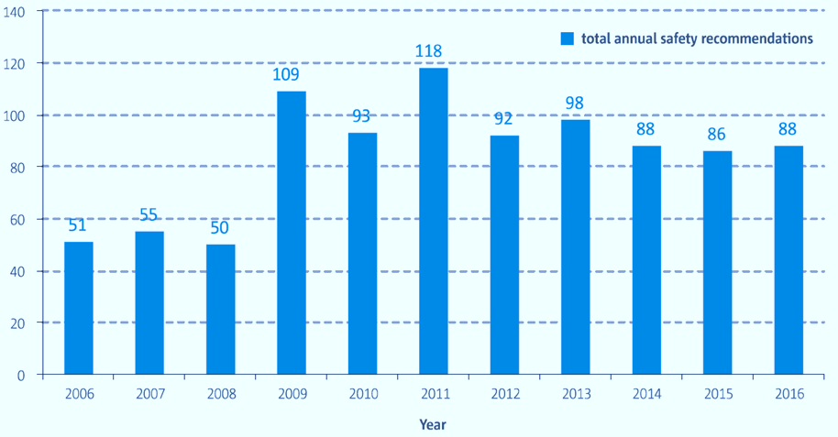
Figure 1 – Safety recommendations addressed to EASA since 2006
In 2016, the safety recommendations were addressed to EASA by the Safety investigation Authorities of 18 different States, in accordance with the percentage distribution shown in Figure 2 between EASA Member States and non EASA Member States and the more specific details provided in Figure 3.
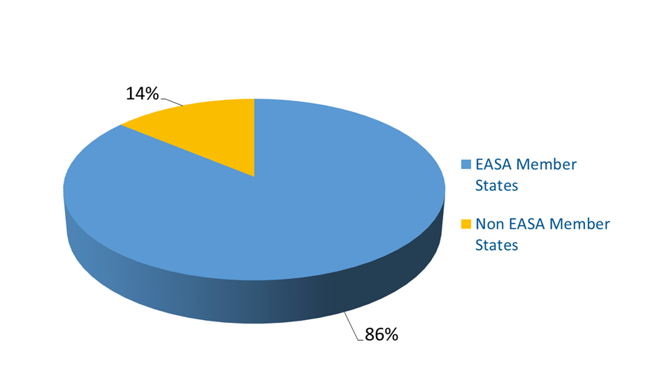
Figure 2 – Origin of Safety Recommendations received by EASA

The 88 safety recommendations received were related to one study and 41 different occurrences comprising 30 accidents and 11 serious incidents. Among them, 40 were classified as being of “Union-wide relevance” (SRUR), and 20 as being of “Global Concern” (SRGC) by the European SIAs.
The safety study, containing one safety recommendation addressed to the Agency, was carried out by the AAIB UK within the scope of General Aviation (GA) and referred to common airworthiness issues related to several fatal accidents involving aircraft registered overseas, but resident and operated within the United Kingdom (UK).

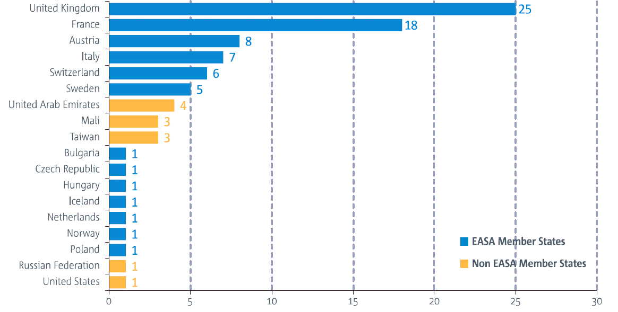
Figure 3 – States contribution to Safety Recommendations received in 2016

Safety recommendations coming from non-EASA Member States mainly addressed actions that had already been identified by EASA and the safety actions were already in-progress. The recommendations were mainly focussed on mandatory upset recovery training, including consideration on initial training, and the extension of the icing environment to be used for the certification of large aeroplanes. In addition, non-EASA Member States recommendations also triggered the development of crash-resistant fuel systems for helicopters to reduce post-impact fire.

Overview of Safety Recommendations replies in 2016
In 2016, EASA issued 196 replies to 177 safety recommendations. Regular updates were provided meaning that there may be several response letters issued for the same recommendation in a given year. The main volume of replies produced in 2016 were EASA responses to recommendations that were received in 2015 and 2016. However, replies to recommendations from earlier years were also issued, per Table 1, for those cases where action follow-up and conclusions were issued, which necessitate updates and/or closure of the safety recommendation.
The 80 final replies sent by the Agency in 2016 closed safety recommendations in accordance with the following EASA response category distribution:
- EASA agreed to take corrective actions on 70 cases either by directly applying the recommended actions as was the case for 41 of them, or by partially agreeing to take corrective action for 29 of them. In partially agreeing, the Agency recognizes the safety issue but took other corrective actions than that which was recommended.
- In other 9 cases, the safety recommendations were evaluated and the safety benefit was not agreed with. Figure 4 below shows this distribution.
Year Recommendation received in | Number of replies sent in 2016 | Including Final Replies
2006 | 3 | 2
2007 | 2 | 0
2008 | 4 | 0
2009 | 6 | 3
2010 | 6 | 3
2011 | 20 | 13
2012 | 5 | 2
2013 | 19 | 6
2014 | 21 | 11
2015 | 30 | 18
2016 | 80 | 22
total | 196 | 80
Table 1 – EASA responses to safety recommendations in 2016 by year received
To follow-up whether or not the competent Safety Investigation Authority (SIA) considers the response/reply as adequate or disagrees with the proposed action that EASA has implemented in compliance with Regulation (EU) No 996/2010.

Figure 4: Safety Recommendation Responses sent in 2016
Figure 5 shows the total number of response assessments that EASA has received, based on the 80 final replies that were sent in 2016. As assessed, 75% of the responses provided by the Agency were deemed to be “adequate”, and 15% as being “not adequate”.
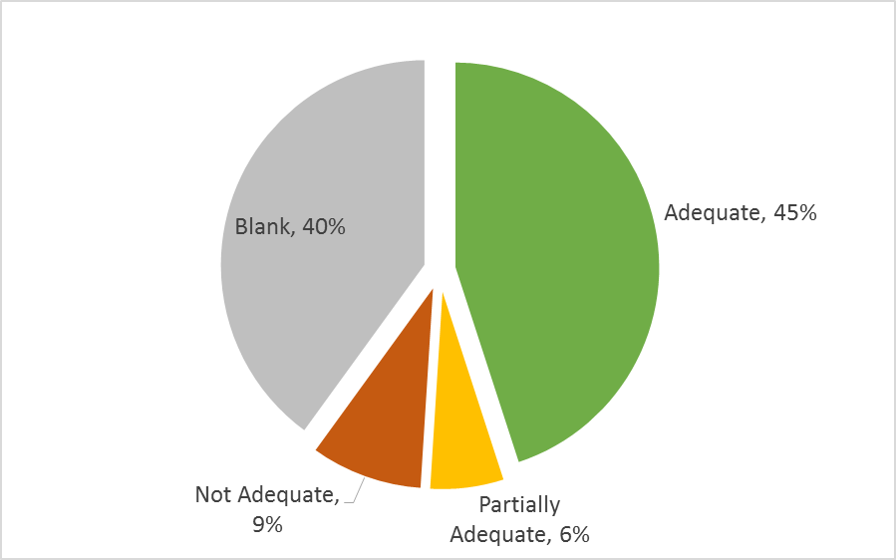
Figure 5: Received response assessments of EASA Final Replies sent in 2016

Key safety topics associated to the follow-up of the SRs
The paragraphs below highlight the safety issues stemming from the safety recommendations received and/or dealt in 2016, together with the EASA corrective actions that were taken in response

Medical and psychological conditions of flight crew
The tragic crash of an Airbus A320 accident in the French Alps on 24 March 2015 due to an intentional descent via the autopilot until collision with terrain, reminded the international aviation community that the medical and psychological conditions of flight crews, if not detected, can lead to a catastrophic outcome.
In the aftermath of the accident investigation led by BEA France 6 safety recommendations were issued to EASA, all classified with Global Concern (SRGC) and Union-wide Relevance (SRUR).
At the date of publication of the Annual Safety Recommendations Review, all of them have been closed with final replies.
Furthermore, to discuss the implementation of these 6 SRs and another set of 6 SRs issued by an EASA-led taskforce convened by EU Transport Commissioner, the Agency hosted two global Aircrew Medical Fitness workshops and launched a survey for operators which led to a revised Safety Information Bulletin (SIB No.: 2016-09) on Minimum Cockpit Occupancy in July 2016.
Finally, EASA published two Opinions as part of Rulemaking Task RMT.0700 ‘Aircrew medical fitness’. The first Opinion includes an update of the rules concerning the medical fitness of pilots (Annex IV (Part-MED) of Commission Regulation (EU) No 1178/2011), and was published in August 2016. The second Opinion was published in December 2016 and includes proposals for new operational rules to better support psychological wellbeing of pilots. EASA is also developing a data repository of medical certificate.

Helicopter Offshore Operations
In 2016, EASA received 20 safety recommendations stemming from the AAIB UK investigation of the Super Puma AS332 L2 accident, registration G-WNSB, which occurred on approach to Sumburgh Airport on 23 August 2013. These proposals addressed survivability after ditching, cockpit image recording, safety management, maintenance, and training for offshore passengers.
From EASA, the main development was the publication of the EASA ED Decision 2016/022/R of 6 October 2016, which addresses the safety risks identified for helicopter offshore operations (HOFO) taking into account new technologies, with a view to establishing a level playing field. The most significant changes are related to training alternatives for passenger briefings, airborne radar approaches, and survivability in the event of a helicopter capsize.
Furthermore, among the most significant initiatives taken on the subject in 2016 should be highlighted:
- The publication of Commission Regulation (EU) 2016/1199 of 22 July 2016 with regard to offshore helicopter operations, with a focus on operating procedures and crew training, flight data monitoring, and occupant survivability on impact with water;
- The establishment of the Helicopter Accident Data Collaborative Analysis Group (HADCAG) to consider appropriate actions to improve the safety of offshore helicopter operations and an offshore helicopter operations safety risk portfolio (SRP) has been compiled, using the occurrence data to assess the risk;

Collisions warning systems for general aviation to mitigate the risk of Mid-air collision/Near mid-air collision (MAC/NMAC)
In 2016, 6 safety recommendations stemming from several occurrences have been received that propose the need for collision warning system for general aviation. In order to mitigate the risk of airborne collisions, these safety recommendations address a wide range of measures, such as general promotion, implementation of standards, expanding requirements for installation (extending minimum equipment) as well as certification of cost-efficient collision warning systems.
In addition to the response to the specific recommendations, the Agency has taken on board the safety issue by including it in the latest version of the European Plan for Aviation Safety (EPAS) 2017-2021 by addressing and taking further actions on MAC/NMAC in general aviation under the umbrella of “General Aviation – Preventing mid-air collisions”.

Erroneous Parameters at Take-off
The investigation reports and studies related to a number of accidents and serious incidents worldwide have highlighted a safety issue related to the use of erroneous mass data or take-off performance data. The analysis conducted showed also that various aircraft types have been involved making this a general safety concern.
The SIB published by the Agency in response to these concerns (SIB No.: 2016-02) was then aimed at:
- Raising awareness of the specific hazard to flight crews, operators and competent authorities;
- Providing recommendations to operators on the completion of a specific safety risk analysis and assessment related to this issue in order to assess the effectiveness of mitigations in place and to determine the need for additional or alternative actions;
- Providing recommendation on training items to be emphasised during flight crew initial and recurrent training in order to increase awareness on the issue; and
- Providing recommendations on the use of the operator’s Flight Data Monitoring (FDM) programme in order to identify precursor events.

Cabin Air Quality
Recommendations have been received on training crews to recognise and manage a cabin air contamination (CAC) event, the mandatory usage of emergency protective equipment, the installation of technical air monitoring systems, such as sensors that have been combined with appropriate filter systems, and also to conduct further research on toxicity aspects.
In 2016 interdisciplinary safety recommendations were also addressed to other ‘non-aviation’ entities, e.g. in the field of occupational safety and health, that recommended research on the impact of contaminated cabin air in aircraft on the human body in order to minimise the potential negative health effects for persons affected.
The two following studies commissioned by EASA have now been completed are available on the EASA website:
- In-flight cabin/cockpit air measurements (ref EASA.2014.OP.16)
- Aviation turbine engine oil toxicity (ref. EASA.2015.HVP.23)
As a follow-up activity, further research has started in a European Commission (EC) study, with technical support from EASA, that will take into account the findings and recommendations from the two EASA studies to develop a comprehensive understanding of the cockpit and cabin air quality.

Aircraft localisation and flight recorders
Several safety recommendations have been received by the Agency encompassing a number of topics associated to this issue, in the broad spectrum of domains that goes from large aircraft engaged in Commercial Air Transport operations till rotorcraft in General Aviation.
Among the actions taken in response, it should be noted that the Agency:
- Has been working within the framework of rulemaking task RMT.0249 with regards to the localization of an aircraft in distress and with a view to facilitating the recovery of flight recorder data, on adapting the certification specifications for large airplanes (CS-25) in order to facilitate the installation approval of a deployable flight recorder on a large airplane;
- Has published the Certification Memorandum CM-AS-008 to increase the rate of success full transmission of the ELT signal;
- Has been working through a number of dedicated rulemaking tasks (RMT.0271, RMT.0272, RMT.0690) to extend the in-flight recording requirements to lighter aircraft, while introducing a specific framework for the protection of airborne image recording.
- Has introduced, through an ED Decision, an extended list of FDR parameters for newly manufactured aircraft.

Risks posed by Lithium Batteries on Board
Safety recommendations of Global Concern have raised the need to minimise the risks associated when transporting of lithium batteries through increasing the awareness of the airline industry and travelling public.
In response, to this first area of concern, the Agency published in 2016 the following SIBs on when a PED becomes dangerous good:
- SIB No.: 2016-04 ‘Carriage of Personal Transportation Devices’, to raise awareness on the transport of small lithium battery-powered personal transportation devices.
- SIB No.: 2016-08 ‘Portable Electronic Devices belonging to the Operator’, to raised awareness about the risks associated with the wide use by aircraft operators of PEDs containing lithium batteries that exceed the limits imposed by the technical instructions (TI).
- SIB No.: 2016-14 (repealed and amended by SR No. 2017-01 on 09 February 2017) ‘Safety Precautions regarding the Transport by Air of Damaged, Defective or Recalled Lithium Batteries’.
Furthermore, safety recommendations also resulted from the investigation of a fire, which was caused by malfunctioning non-rechargeable lithium-metal battery in the ELT on a Boeing B787 that was parked on at London Heathrow Airport on 12 July 2013. On this latter topic, in 2016 the Agency published a Special Condition addressing the specific risks of non-rechargeable lithium batteries for new installations, which is applicable to all new design changes introducing such batteries for CS 25 aircraft.

Loss of Control Prevention and Recovery Training
Safety recommendations EASA received in 2016 stemming from recent loss of control accident investigations address flight crew training improvements with the specific objective of providing the flight crew with the necessary competencies to identify and prevent stalls and to recover from developing or developed upsets.
Among the several initiatives undertaken by the Agency on this topic, on 15 July 2016 was launched, In line with the Upset Prevention and Recovery Training (UPRT) development, the RMT.0196 ‘Update of flight simulation training devices requirements’, with the publication of the associated Terms of Reference.
Within the context of the actions addressing risk associated with upset, loss of the normal flight path, or loss of control during the go-around manoeuvres as illustrated for instance in the BEA ASAGA Study, the Agency published on 14 September 2016 the first deliverable of RMT.064 “Requirements for air traffic services”, NPA 2016-09(B).

Security Related (SEC) events
Events like Metrojet flight 9268 in 2015, and Malaysian Airlines flight MH17 in 2014 showed that aviation is being challenged by new threats and emerging risks associated to Security Related (SEC) events and led to the issuance of specific safety recommendations.
To tackle this issue, on 17 March 2016In 2016, the European High Level Task Force on conflict zones, which was created in occasion of the high level meeting co-organised by EASA and CAA Romania, issued its final report to European Commissioner for Transport, with a proposal to set-up a European level Conflict Zone Alerting System, with cooperation between Member States, European institutions, EASA and other aviation stakeholders.
Furthermore, a Conflict Zones Network of Focal Points (RCZ Network) was established, composed of focal points from EASA, the European Commission, the European External Action Service (EEAS) and focal points designated by the EU Member States who are willing to contribute. The network serves as a platform for sharing information on conflict zones and consults on draft EASA conflict zones publications (CZIB). Since then, the Agency published several Conflict Zone Information Bulletins (CZIB) containing information or recommendations regarding risks to civil aviation arising from Conflict Zones (RCZ).

Unmanned Aircraft (Systems)
In 2016, 5 safety recommendations were issued by the Italian – ANSV stemming from a study related to “Interference of unmanned aircraft in the Italian airspace with associated risks for the safety of the flight of manned aircraft” covering the safety topics of aircraft certification, aircraft operations, oversight and auditing, and design, production, and manufacturing. Although they were not addressed to EASA, due to the emerging nature of the topic and their classification as SRUR and SRGC, they were considered by the Agency in the context of the European Aviation Safety Task Force, where the risks resulting from collisions between drones - of varying masses and different categories of manned aircraft, considering their design characteristics and operational requirements - have been assessed.
As a result, the need for further coordinated and collaborative research program was identified, whose outcome should help to:
- Confirm operational limitations associated to drone categories;
- Influence the design of drones to minimize the risk if an impact occurs;
- Categorize new drone designs that utilize new drone technologies; and
- Prevent unnecessary regulatory actions from affecting the drone and aircraft industries.

CONCLUSIONS
The Annual Safety Recommendation Review is a mature document published by the Agency that provides a comprehensive view of the actions taken in response to the Safety Recommendations received.
In 2016, the 196 replies issued by the Agency outlined several of the key safety topics that are currently part of the EPAS and are included in the safety risk management process.
The analysis of the follow-up of the safety recommendations provided by the Agency, based on the assessments received, shows a very good acceptance of the measures put in place and the conveyed associated rationale.

https://www.easa.europa.eu/document-library/agency-decisions/ed-decision-2016022r
https://www.easa.europa.eu/document-library/research-projects/easarepresea20144

